Project Title:
Deep Learning Fundus Image Analysis for Early Detection of Diabetic Retinopathy
Team ID: LTVIP2026TMIDS24563
Team Members:
- Gade Yasaswi
- Kanubaddi Jahnavi
- Tata Sneha

Phase 1: Brainstorming & Ideation

Objective
The objective of this project is to design, develop, and deploy an intelligent deep learning system capable of detecting Diabetic Retinopathy (DR) at an early stage using retinal fundus images. Early identification of DR is critical to prevent irreversible vision loss. The system aims to provide automated, accurate, and fast predictions that can assist ophthalmologists and healthcare providers in large-scale screening programs. Additionally, the project seeks to reduce dependency on manual diagnosis, minimize screening time, and enable accessibility in remote and rural areas through a web-based solution.

Problem Statement
Diabetic Retinopathy is a serious complication of diabetes that damages retinal blood vessels over time. In the initial stages, patients often do not experience noticeable symptoms, making early diagnosis extremely challenging. Traditional screening methods rely on expert ophthalmologists manually examining fundus images, which is time-consuming, costly, and not scalable for growing diabetic populations. In many rural or underdeveloped regions, access to trained specialists and diagnostic equipment is limited. These challenges highlight the need for an automated, scalable, and accurate system that can detect diabetic retinopathy early and support timely medical intervention.

Customer Problem Statement Template
PS-1: Diabetic Patient

- I am: A diabetic patient concerned about my eye health

- I’m trying to: Detect eye damage at an early stage

- But: Regular eye checkups are infrequent and costly

- Because: Early diabetic retinopathy does not show symptoms

- Which makes me feel: Anxious about potential vision loss

PS-2: Elderly Diabetic Patient

- I am: An elderly person with long-term diabetes

- I’m trying to: Monitor my retinal health regularly

- But: Hospitals and specialists are far away

- Because: Delayed diagnosis worsens eye conditions

- Which makes me feel: Worried and helpless

PS-3: Ophthalmologist

- I am: A medical professional handling many patients

- I’m trying to: Screen large numbers efficiently

- But: Manual grading of fundus images is slow

- Because: Patient inflow is very high

- Which makes me feel: Overburdened and stressed

PS-4: Rural Healthcare Worker

- I am: A healthcare worker in a remote area

- I’m trying to: Identify DR cases early

- But: There is a lack of eye specialists

- Because: Early treatment prevents blindness

- Which makes me feel: Concerned about patient outcomes

Proposed Solution

The proposed solution is a deep learning–based retinal fundus image analysis system that automates the detection of diabetic retinopathy. The system uses a Convolutional Neural Network (CNN) trained on labeled fundus images to learn discriminative retinal features such as microaneurysms, hemorrhages, and exudates. A web-based interface allows users to upload fundus images and receive diagnostic results in real time. This approach ensures accuracy, scalability, and reduced diagnostic effort.
    - Data Source

      - Retinal fundus image datasets collected from publicly available medical repositories

      - Images include both healthy and diabetic retinopathy cases

      - Data is labeled by medical experts or verified datasets

      - Images are stored in standardized formats for consistent processing

    - Solution Workflow Step 1: Data Collection
      - Gather retinal fundus images from medical datasets

      - Separate images into training, validation, and testing sets

Step 2: Image Preprocessing

      - Resize images to a fixed input size

      - Normalize pixel values for uniformity

      - Enhance contrast and remove noise

      - Apply data augmentation to improve generalization

Step 3: Model Development

      - Design CNN architecture with convolution, pooling, and dense layers

      - Train the model using labeled fundus images

Step 4: Model Evaluation

      - Evaluate using accuracy, precision, recall, and F1-score

      - Analyze confusion matrix

Step 5: Prediction & Output

      - Classify images as DR detected or not detected

      - Display results on the user interface

Target Users
Diabetic Patients

- Early awareness of eye disease

- Reduced risk of vision loss

Ophthalmologists

- Faster screening and reduced workload

Hospitals

- Cost-effective mass screening

Rural Clinics

- Remote diagnosis support

Healthcare Startups

- Integration into telemedicine platforms

Expected Outcome
- Accurate deep learning model for DR detection

- Automated screening system

- Faster diagnosis compared to manual methods

- Reduced dependency on specialists

- Improved healthcare accessibility

Phase 2: Requirement Analysis

Prerequisites and System Requirements
- Python environment for model development

- GPU support for faster training (optional)

- Sufficient RAM for image processing

- Storage for datasets and trained models

Technical Requirements
    - Languages & Libraries

      - Python for model development

      - TensorFlow or PyTorch for deep learning

      - OpenCV for image processing

      - NumPy and Pandas for data handling

      - Matplotlib for visualization

    - Development Tools

      - Jupyter Notebook for experimentation

      - Google Colab for GPU acceleration

      - VS Code for development and debugging

    - Dataset Requirements

      - High-resolution retinal images

      - Balanced classes

      - Labeled training data

Functional Requirements
- Image upload functionality

- Automatic preprocessing

- Model prediction

- Result visualization

Constraints & Challenges
- Variability in image quality

- Limited dataset size

- Model interpretability

- Computational complexity

- Data privacy concerns

Phase 3: Project Design

System Architecture Diagram
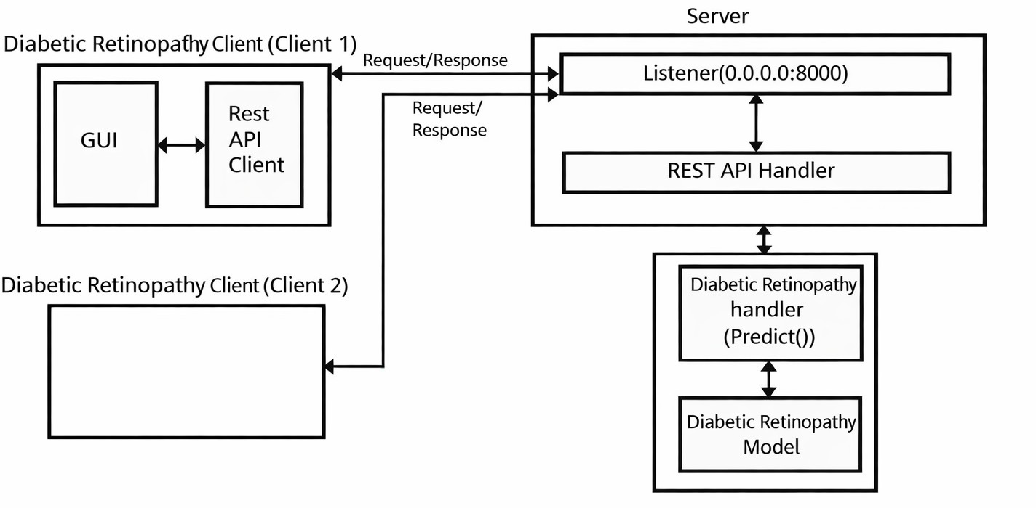

The system follows a client–server architecture with a clear separation between user interface, backend processing, and deep learning model. The client communicates with the server through REST APIs, ensuring scalable and secure data exchange.

User Flow

- User uploads fundus image

- Backend processes image

- Model predicts disease

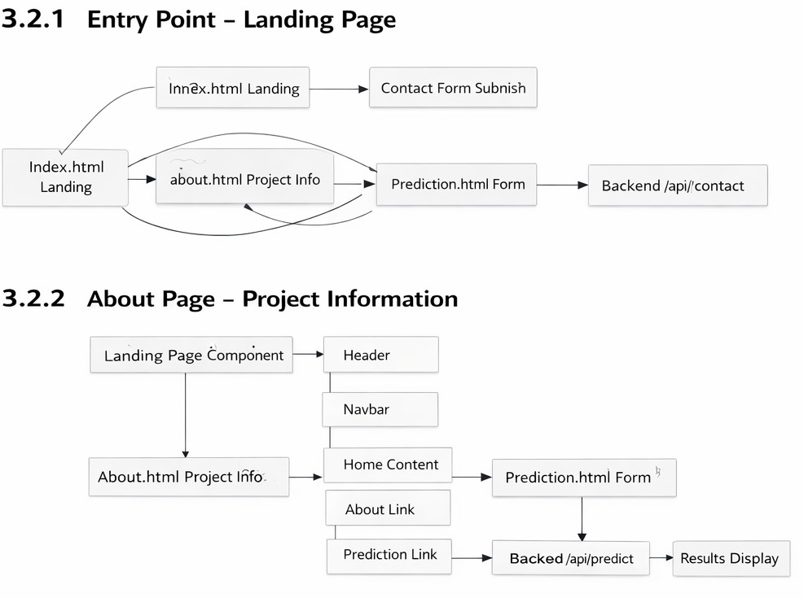
- Result displayed

UI/UX Considerations
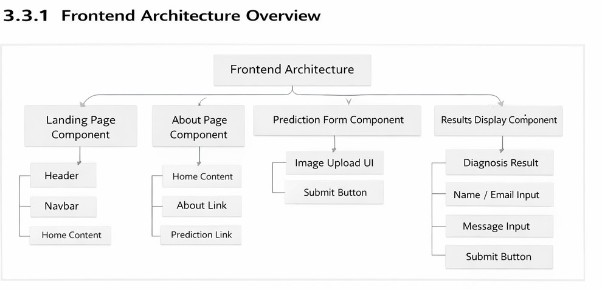

- Simple layout

- Clear instructions

- Responsive design

- Easy navigation

Phase 4: Project Planning (Agile Methodology)
Each sprint focuses on incremental development:

- Sprint 1: Data preparation

- Sprint 2: Model development

- Sprint 3: Training and tuning

- Sprint 4: Integration

- Sprint 5: Testing and documentation

Phase 5: Project Development

Technology Stack Used
- Frontend: HTML, CSS

- Backend: Python (Flask)

- Deep Learning: TensorFlow / PyTorch

Development Process
Image Processing

- Cleaning and normalization

Model Training

- CNN training and optimization

Evaluation

- Metric-based validation

Challenges & Fixes
- Overfitting → Data augmentation

- Imbalanced data → Class weighting

- Long training time → GPU usage

Phase 6: Functional & Performance Testing

Functional Testing
- Image upload tested

- Prediction accuracy verified

Performance Testing
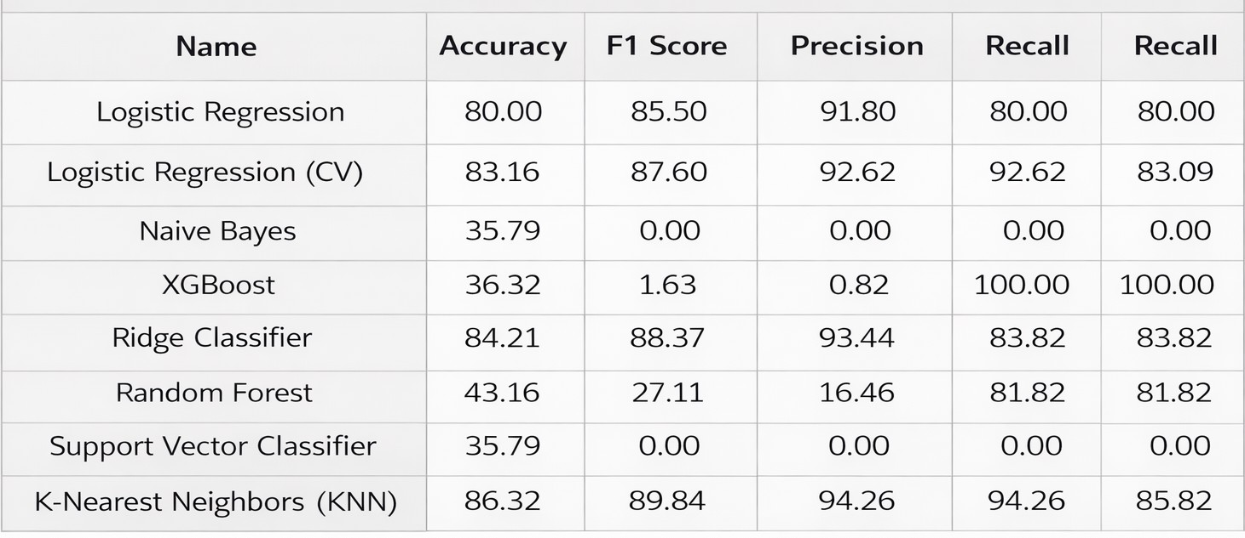

- High accuracy achieved

- Low response time

Bug Fixes & Improvements
- Improved preprocessing

- Optimized architecture

Final Validation Checklist
- Functional requirements met

- Reliable predictions

- User-friendly interface

Conclusion
The project successfully demonstrates how deep learning can be used to detect diabetic retinopathy at an early stage using retinal fundus images. The system is scalable, accurate, and suitable for real-world healthcare applications.

Future Scope
- Multi-class DR severity detection

- Explainable AI integration

- Mobile application development

- Integration with hospital systems

